Exp no:6 Determination and plotting of Capacitance of parallel plate capacitor in three different dielectric medium with specific area, dielectric thickness and various dielectric constant.

Aim:
To write program for capacitance of parallel plate capacitor in three different dielectric media using SCILAB.

Software required:
- SCILAB version 6.0.1

Theory: Program:

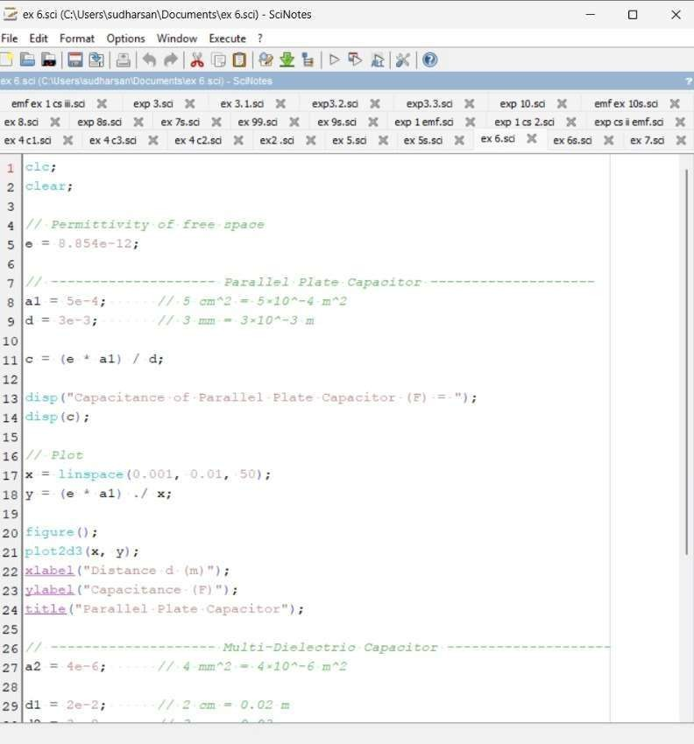

Output:

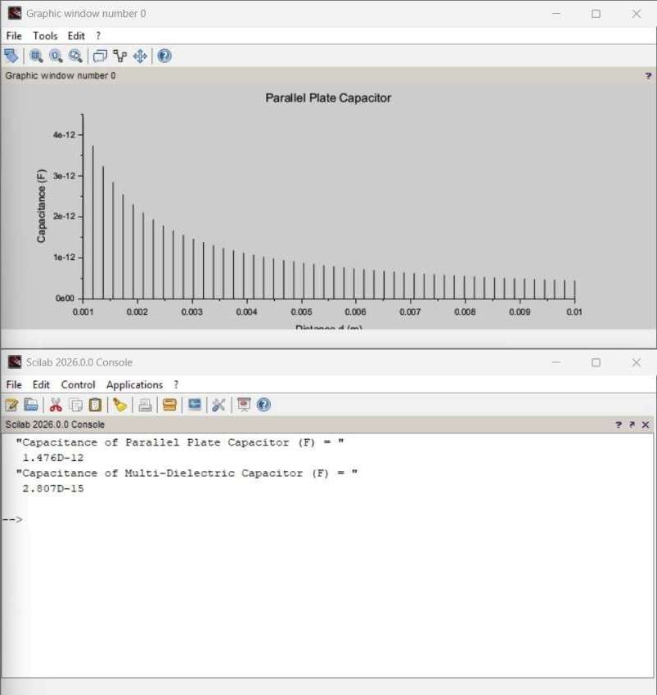

Calculation:
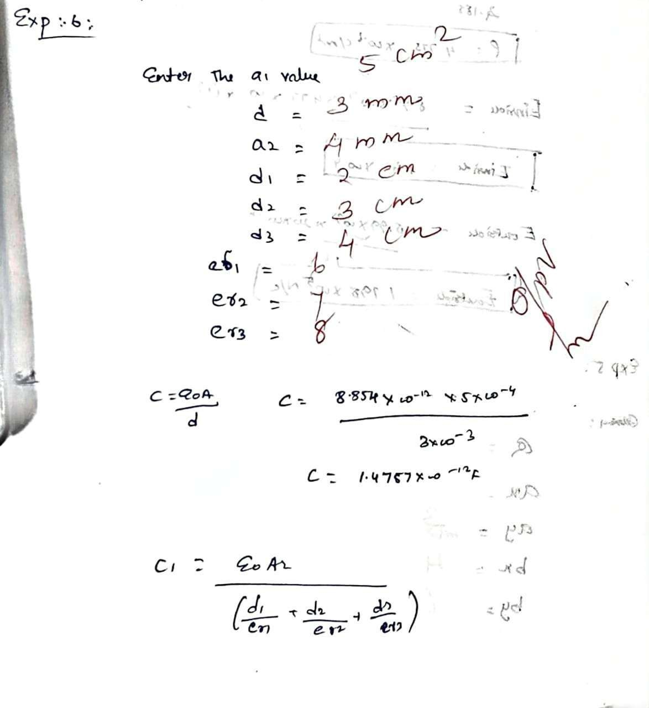
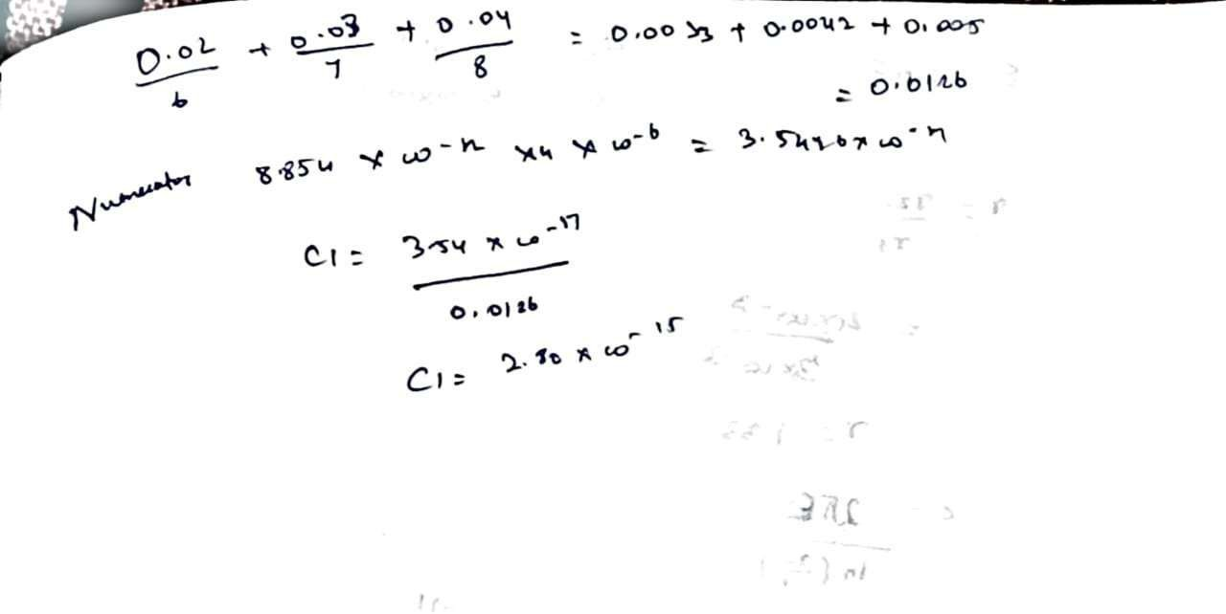

Case 1:
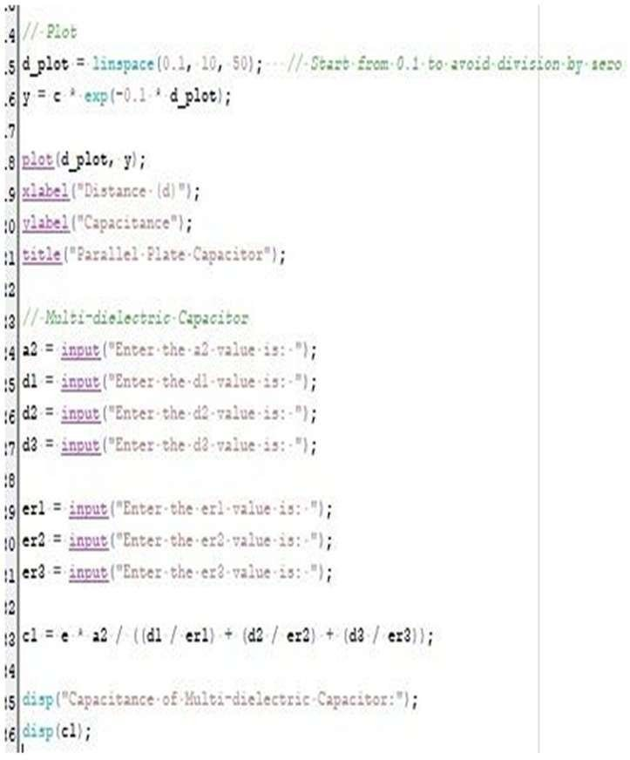

Output:

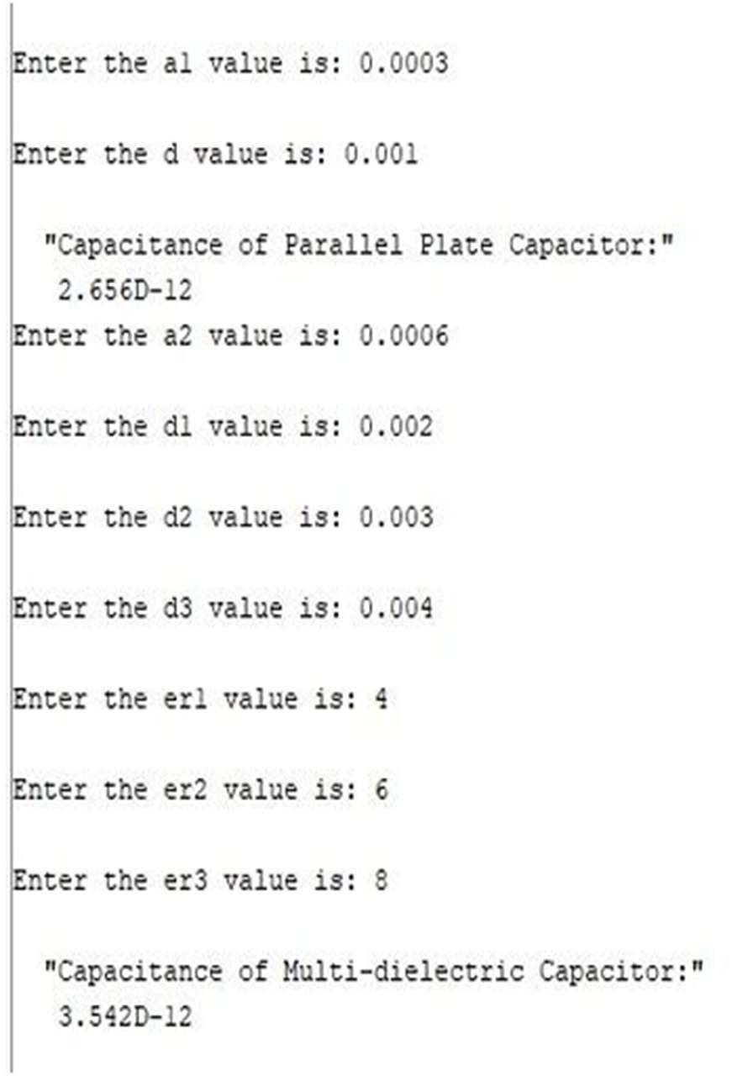
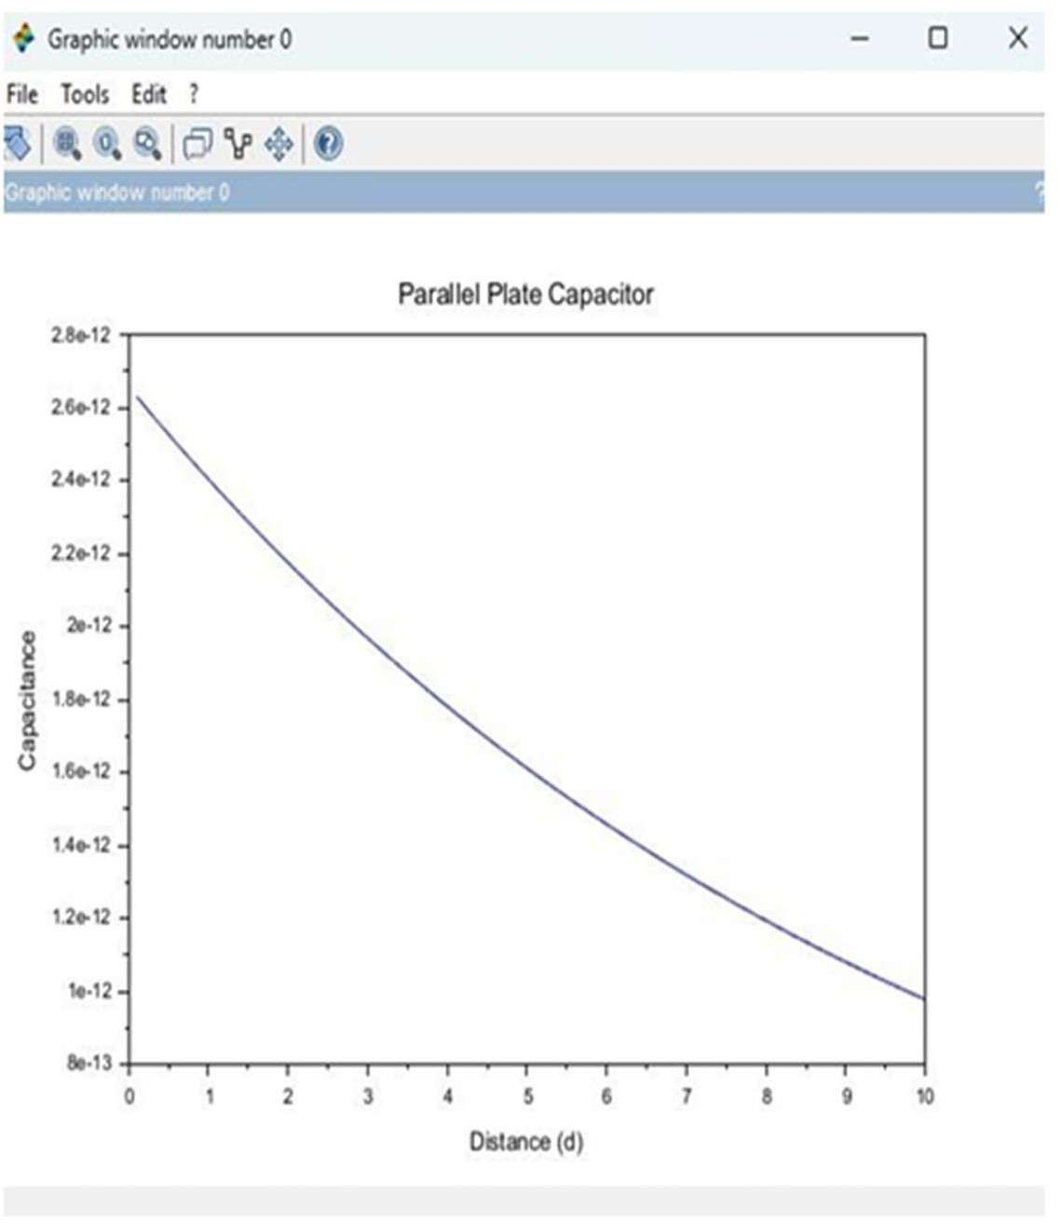

Case 2:

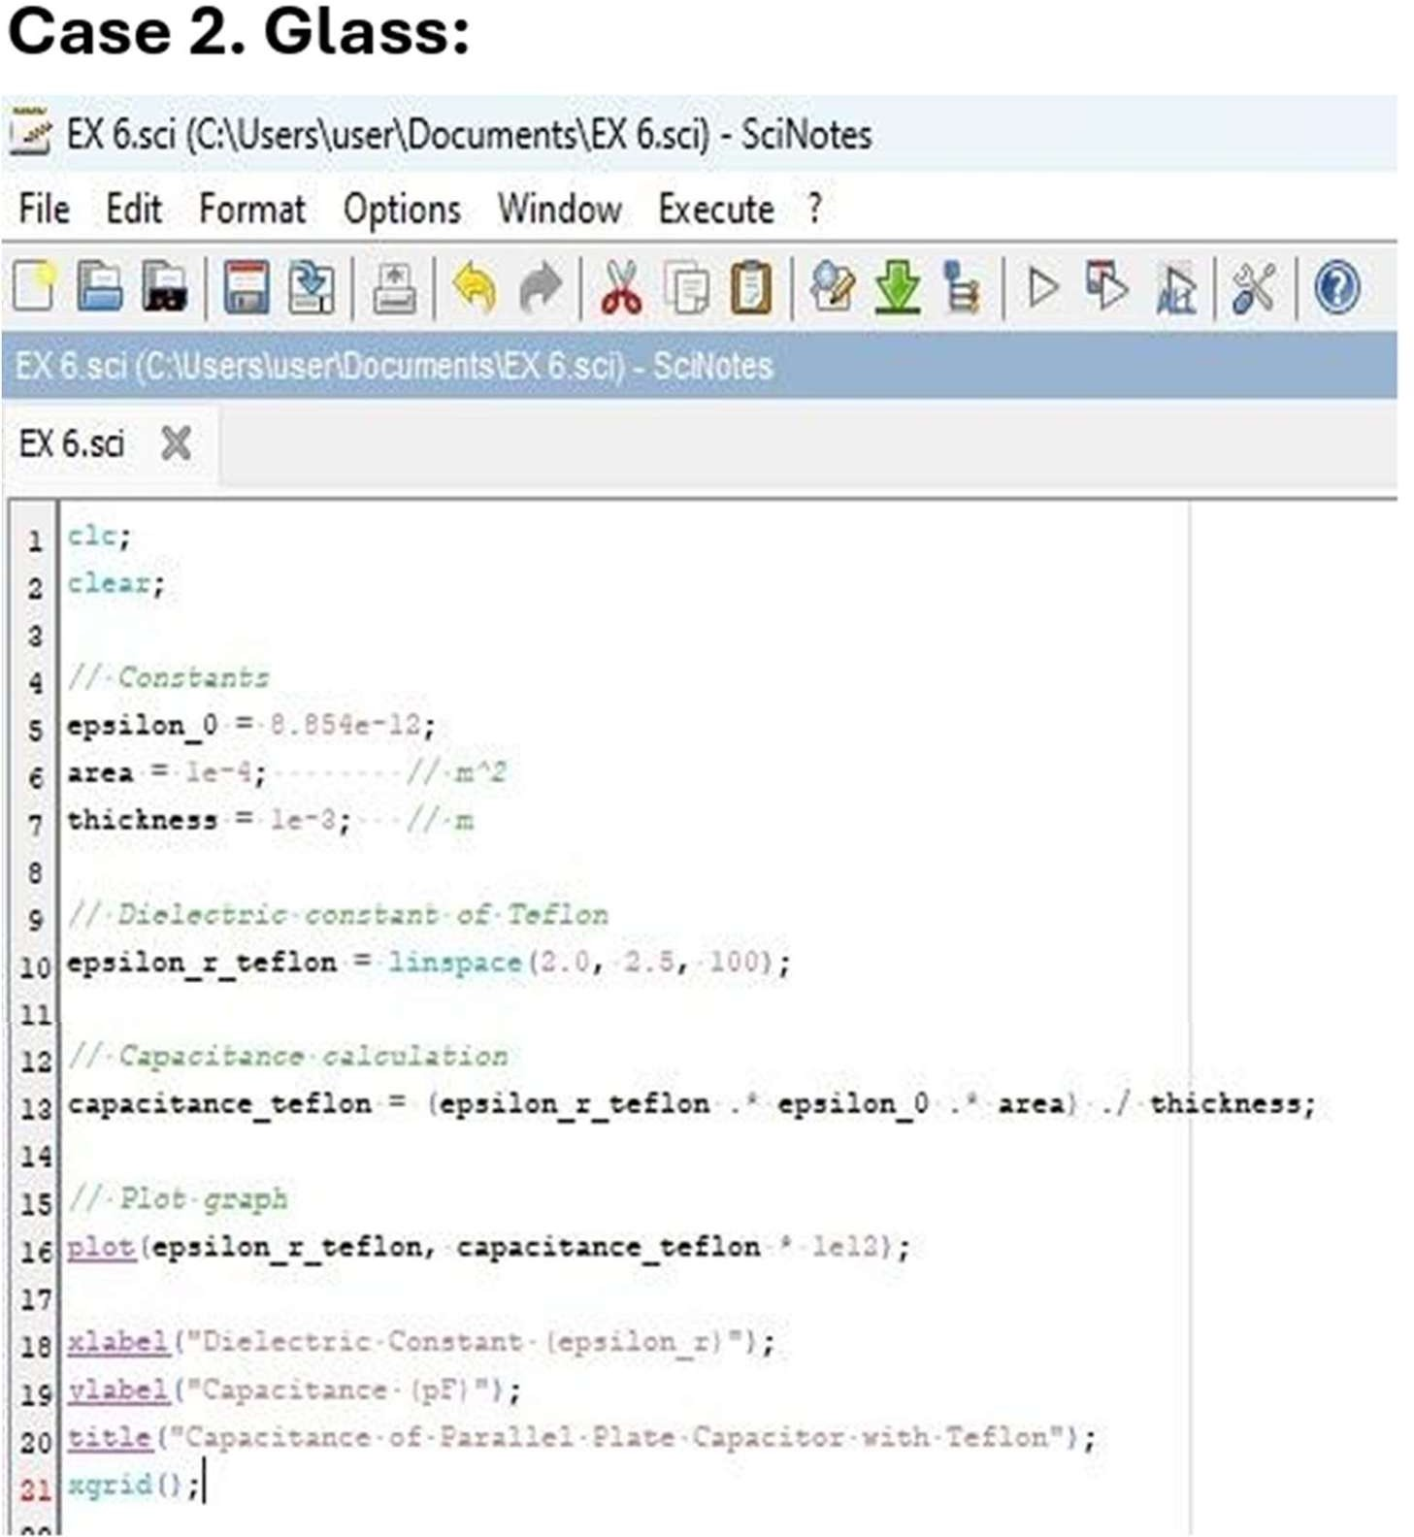
Output: Case 3:
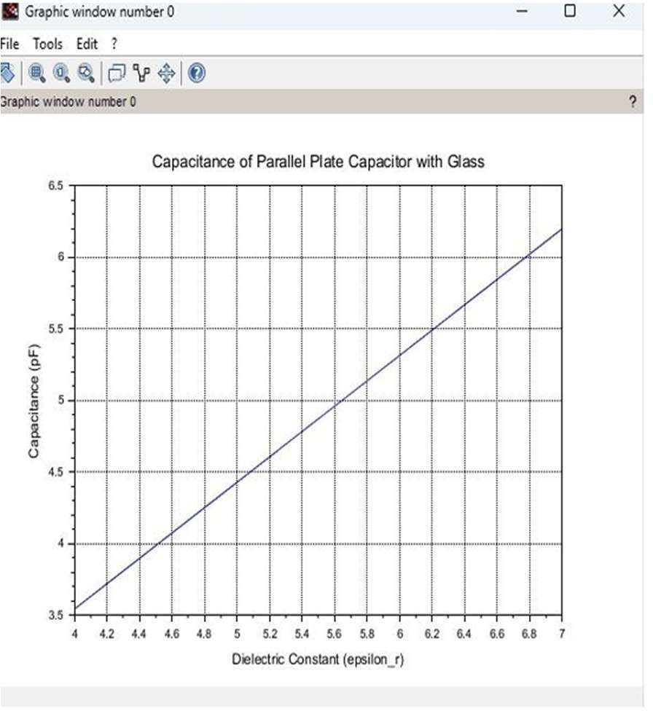

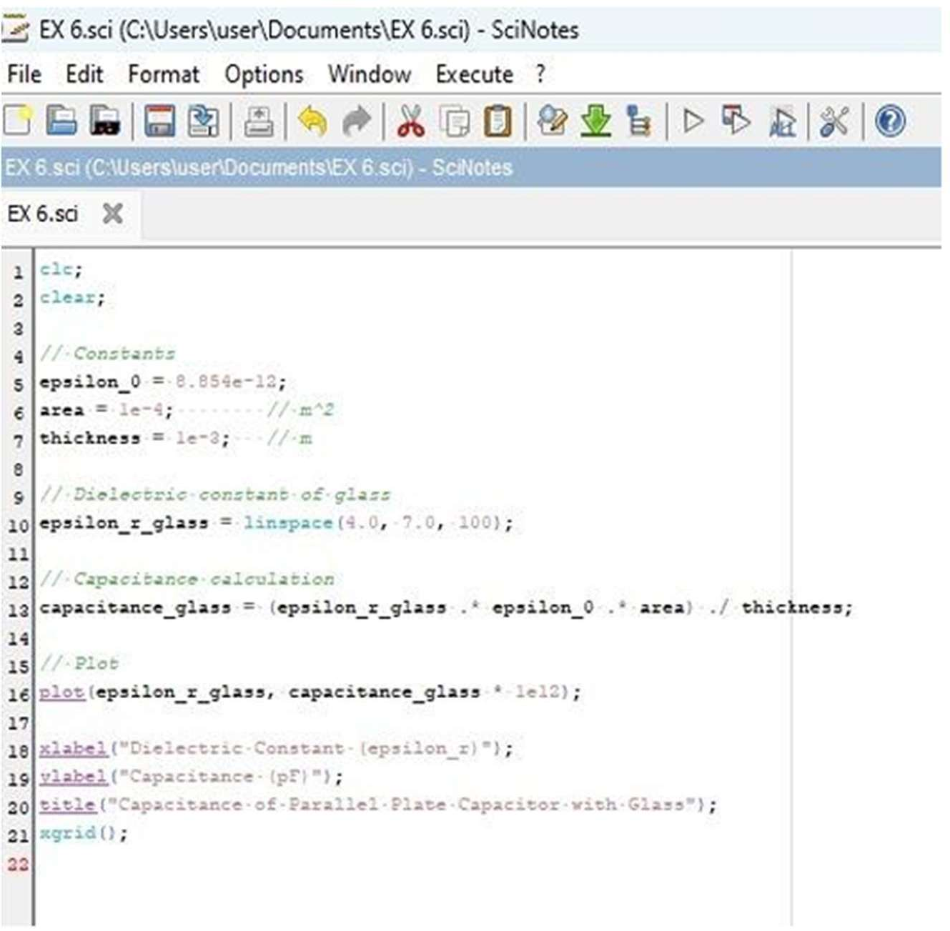

Output:
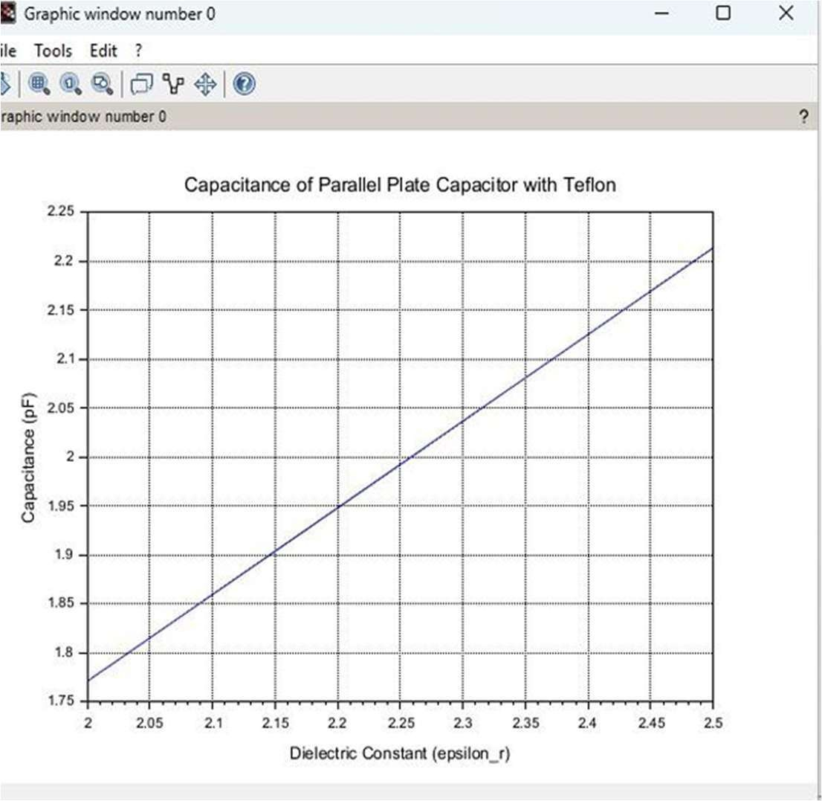
Result : Thus the program was verified for capacitance of parallel plate capacitor in three different dielectric media using SCILAB was successfully.

